Jackson Momm-White
Devin McGowan
J.P. Berrettini

Taranis Mountainboards
Part 1
Foundations and Context
Basic Information:
Company name: Taranis Mountain Boards
Type: Manufacturing and Online Retail of Electric Skateboards
Location: Concord, California

What we do:
Taranis Mountain Boards is a manufacturing and online retailer selling a premium off-road electric skateboard with built-in suspension and a high-torque engine. This unique transportation device allows easy movement uphill at 50 degrees, 20 degrees higher than our closest competitors, Cycleagle and Raldey.

Our Mission:
We want to manufacture premium mountain boarding equipment that makes the sport more accessible to the general population while improving the experience for current users.

How we will make money and compete:
We compete based on quality, differentiation, and customer service. Our mountainboards are the premium product on the market, with features that no other products have. While most traditional mountain boards are man-powered, like skateboards, Taranis makes battery-powered boards. Battery power allows riders to quickly go up steep hills and extends the range of their adventure. We also offer a more comprehensive array of products than any other mountainboarding company, with a selection that ranges from expert boards to commuter boards for city transportation.

Industry: Manufacturing

Why we Chose California:
From surfing to mountain biking, California is the home of all things extreme sports. Known for its beautiful weather, history of technology and engineering, and laid-back lifestyle, California provides the perfect home for Taranis. Since it is such an extreme sports hotspot and the birthplace of mountainboarding, plenty of local customers are sure to be there. And given Silicon Valley’s history of technological innovation, there will be no lack of qualified candidates to help us design and improve our product.

Manufacturing Outlook in Concord, California:
California presents a fantastic location for a manufacturing business. They are responsible for the lion’s share of manufacturing production in the Western United States and are head and shoulders above other states regarding productivity. According to BLS, California has the highest employment rate in production occupations. All of these numbers tell me that plenty of employees would like to work in manufacturing. Since California is known for having a venue for many outdoor activities, it’s fair to assume that there will be a labor market and a market for the product in the area. While much of America has steered away from manufacturing, California has remained a prominent location for manufacturing businesses (BLS, 2020).
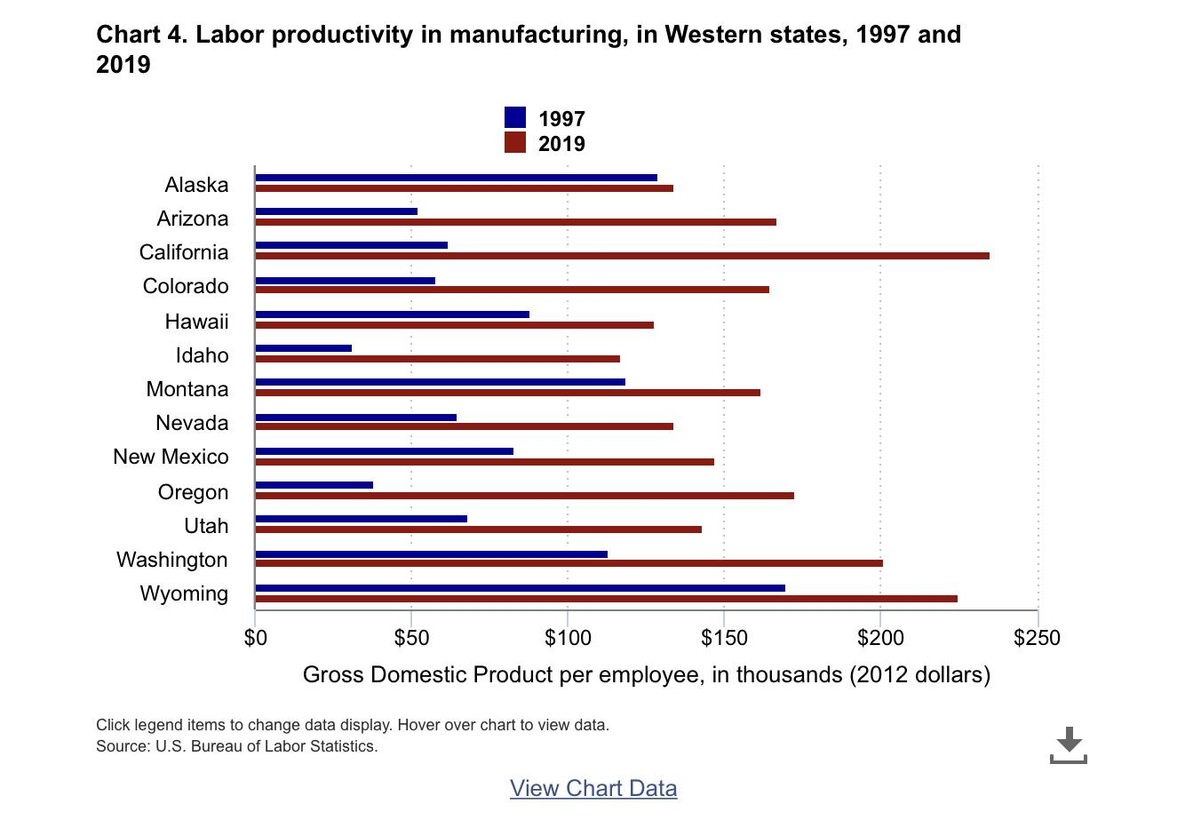
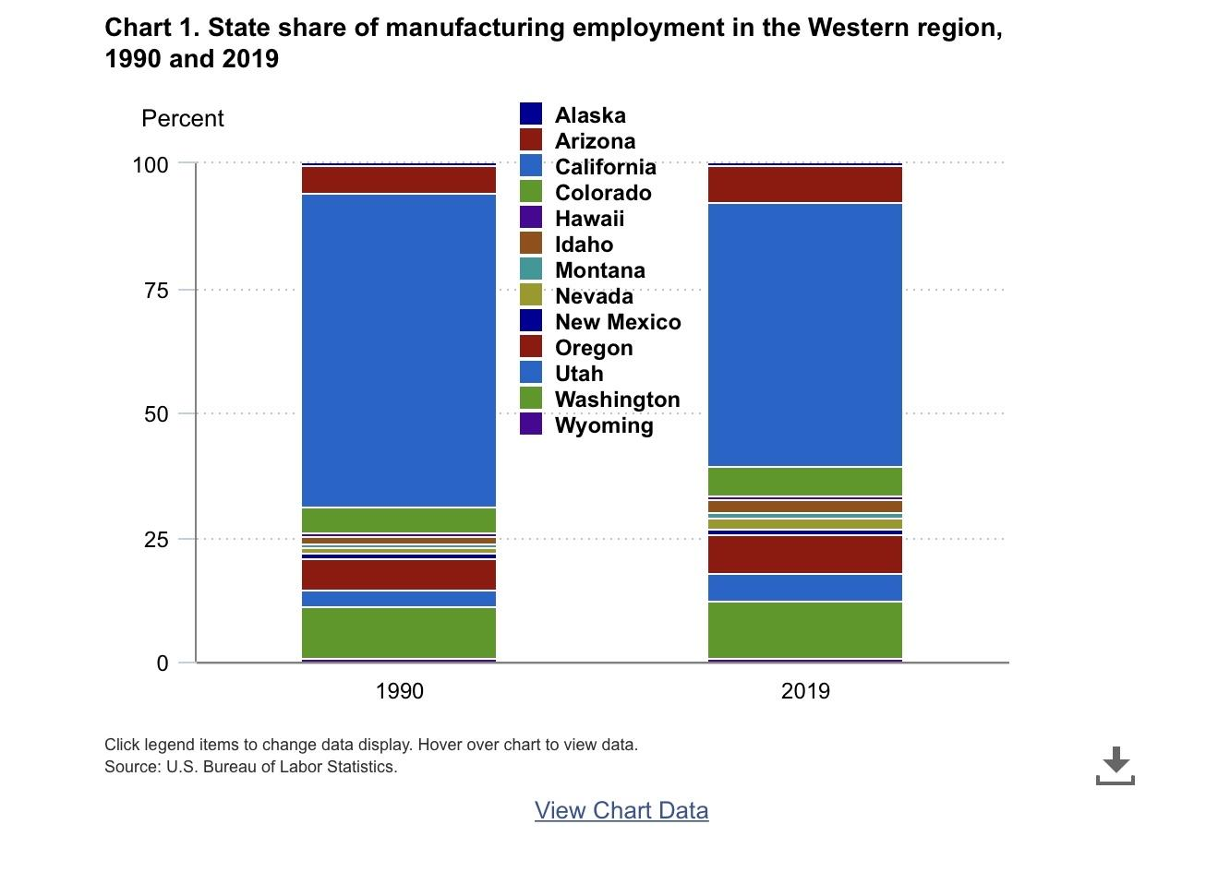
Competition for employees:
We will be competing with large firms for engineers. Many of these firms are searching for the same position as Taranis; engineers who can also serve as project managers.

Key Employee Position: Production Engineer

Diversity Statement:
Without a diverse set of ideas from people worldwide, mountainboarding as we know it wouldn’t exist. At Taranis Mountainboards, we understand the value of diversity and are attempting to share this sport with everyone.

Employment policies:

Safety: Engineers will be working with hazardous equipment. Electric shocks, pinched extremities, and heavy equipment pose a risk to workers. For this reason, we will require a safety inspection before resuming work at any time, and at least two employees to be working in the shop at all times.

Diversity & Inclusion: Women in STEM programs face adversity, but we want to ensure they are welcome and valued as equals. Taranis will require that at least one woman be interviewed when searching for engineers. We also want to ensure that we are a racially diverse company. About 58% of Concord residents are white, meaning there is ample opportunity to hire a racially diverse group of people. At least of ⅓ interviewees must be non-white residents.

Overtime Pay: During busy periods at Taranis, some employees will have to work overtime for us to reach our production goals. Most employees at Taranis will receive x1.5 for overtime. However, the production engineer will receive 1% of all profits generated during overtime. We have this policy to reward the production engineer for their increased responsibilities and creating a product that sells well. Taranis is willing to consider applying this overtime pay system to other groups of employees depending on company growth.

Functional Decisions

Position: Production Engineer
The most important job for this business will be the production engineer that brings the product to life. They will conduct research & development and build prototypes of the design.

Job Description:
Title: Production Engineer

Position Description: The production engineer will primarily be responsible for designing products and managing projects.

Major Areas of Responsibility:
- Product Perfection/redesign
- Project management
- Research & Development

Primary Objectives:
- Improve current models
- Researching and Developing New Prototypes
- Keeping Up with Demand

Specific Responsibilities:
- Ordering, tracking, and organizing raw materials
- Collaborating to facilitate improved designs
- Research & development of product
- Design an aesthetically pleasing product
- Program robotics systems
- Work with athletes to determine their wants and needs
- Monitor the production/assembly process

Abilities:
- Apply constructive criticism to improve prototypes
- Able to work within teams
- Abstract problem-solving
- Delegation
- Identify the needs of each target market
- Multitasking

Skills:
- Design
- Knowledge of “Computer Systems” for engineering

Knowledge:
- Robotics
- Electrical/Mechanical Engineering
- Basic mountainboarding knowledge (preferred)

Education/Experience required:
- Two years of engineering experience (preferred)
- Certified Professional Engineer (PE)

Physical Demands:
You must be able to do skilled work with your hands
You must be able to do minor lifting (no more than 50 lbs)

Work Environment
Mountain boarding is about improving, pushing your limits, and having fun. Why should working at a mountain boarding company be any different? Although we work hard and have clear goals, Taranis doesn’t let that interfere with our company culture. We want you to be able to improve, push limits, and have fun at work and outside of work, which is why employees have unrestricted usage of our stock of mountain boards.

Work Schedule:
Monday-Friday (9:00 A.M.-5:00 P.M.)
*Work schedules are subject to change depending on order volume. When production engineers work over 40 hours a week, they will receive 1% of all profits generated during that time.

Compensation:
Salary: $100,000/ Year
Benefits:
- Three months paid maternity leave
- Federal Holidays off
- Access to Taranis products
- Paid overtime
- 1% commission during overtime
- Basic health insurance plan

Similar Job Postings:
Since most mountainboarding companies are small organizations, I couldn’t find job postings for positions at a mountainboarding company. The best comparison was for electrical engineers that deal with product development. The CBR Group, a company near Concord, California, had a job posting for an electrical engineer in charge of developing certain products. Although the position is not tailored to designing outdoor recreation products, it is a similar job. This company used its job positing to help candidates self-select by laying out expectations for candidate experience, education, and competencies. I thought that outlining specific competencies and explaining in which ways they expect that competency to be met makes perfect sense for such a competency-driven position.
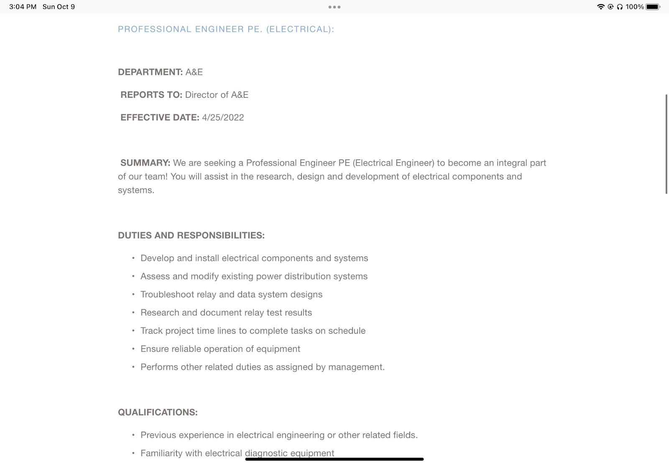
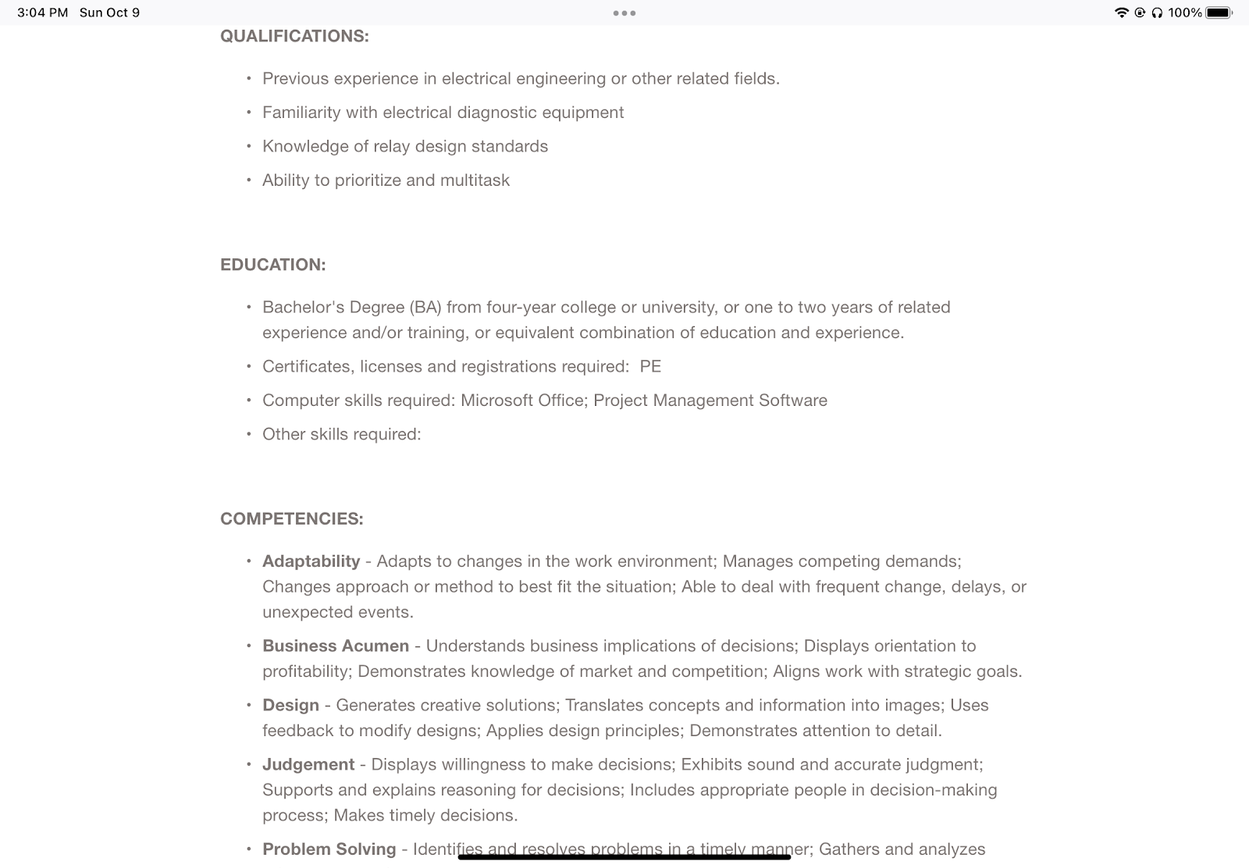
The best comparison to mountain boarding is a mountain biking company. We initially thought that skateboard companies would make for the best comparison, but the culture and company structure of biking more closely resembles that of mountainboarding. We examined job postings for engineers at Cannondale and found that they provided much more information about their company culture than CBR Group did.
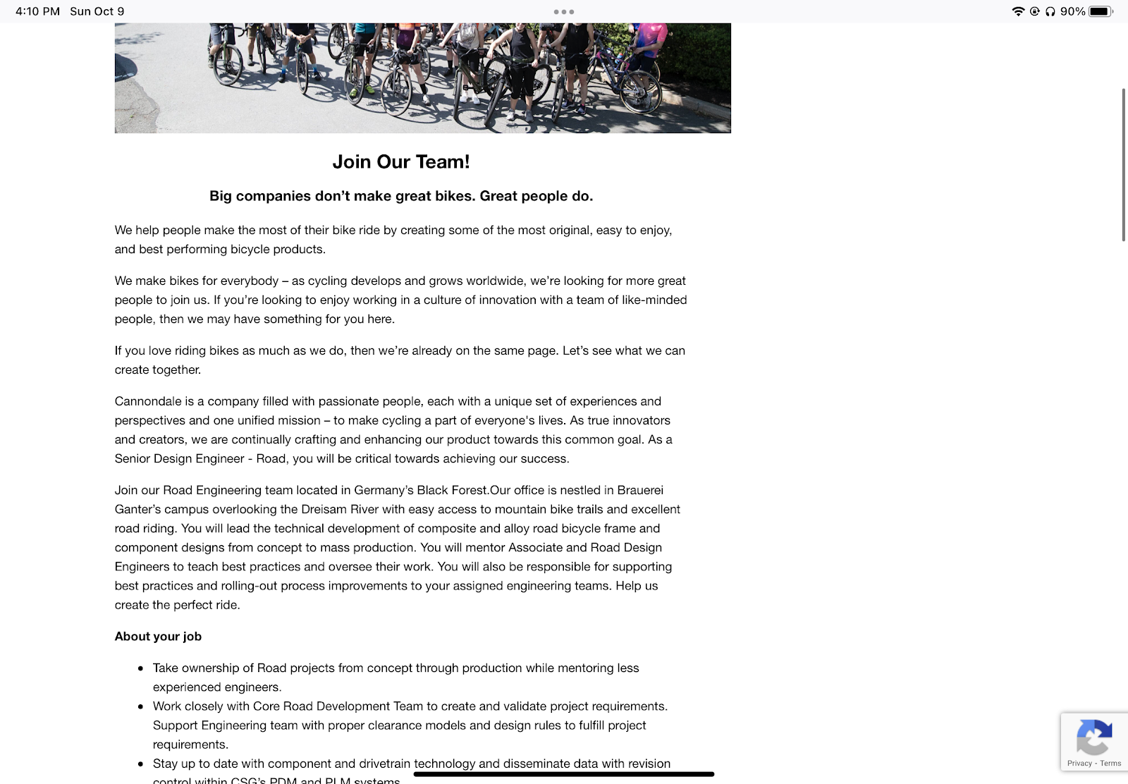
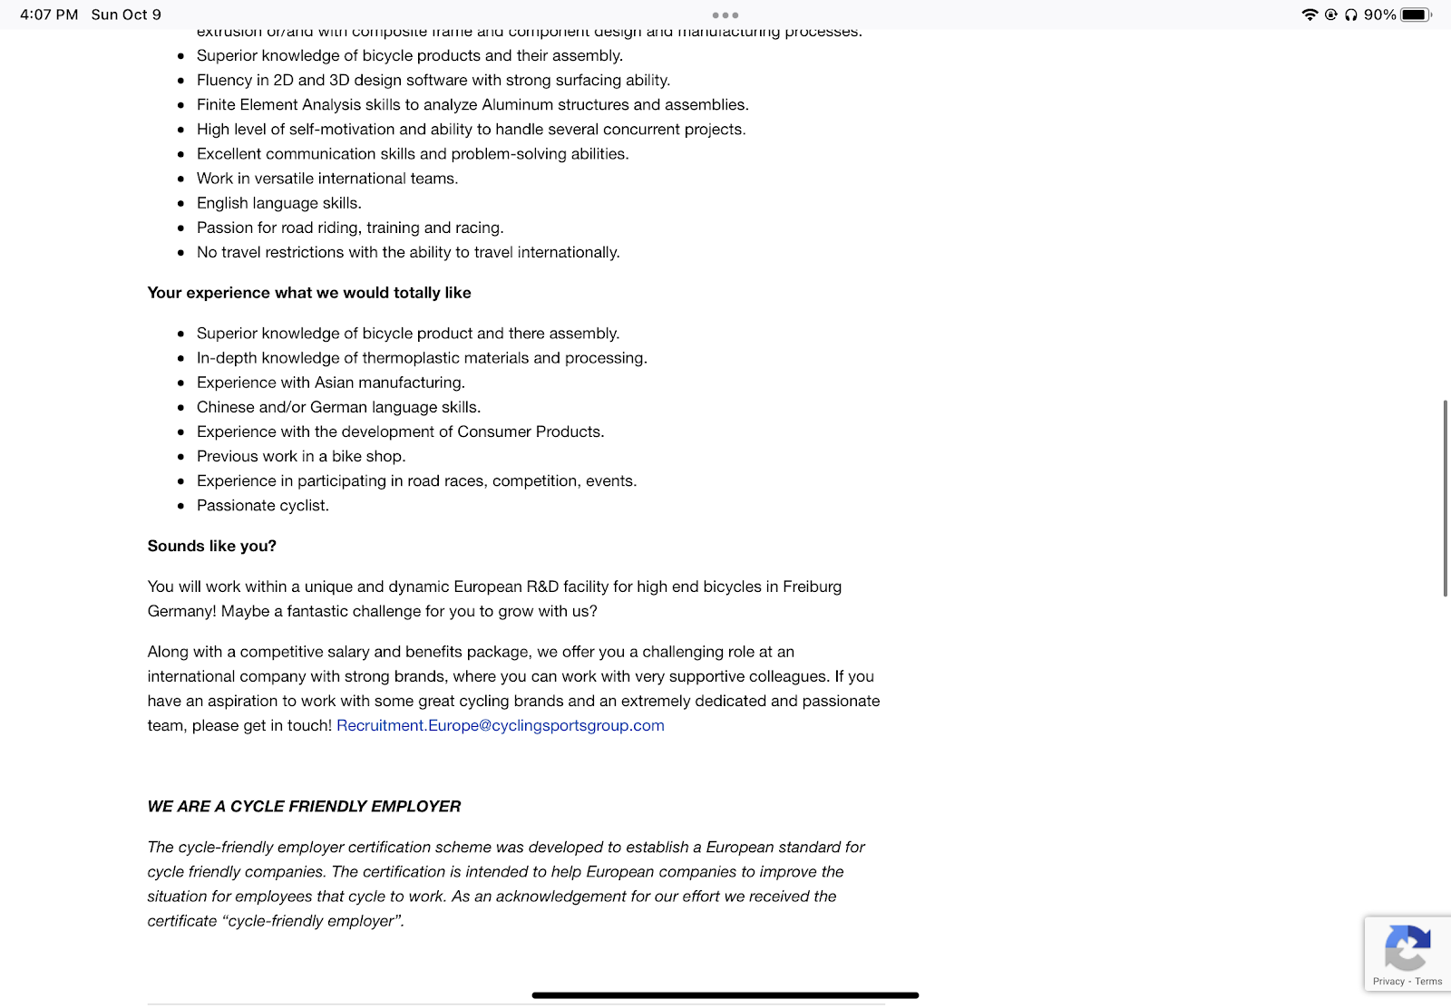
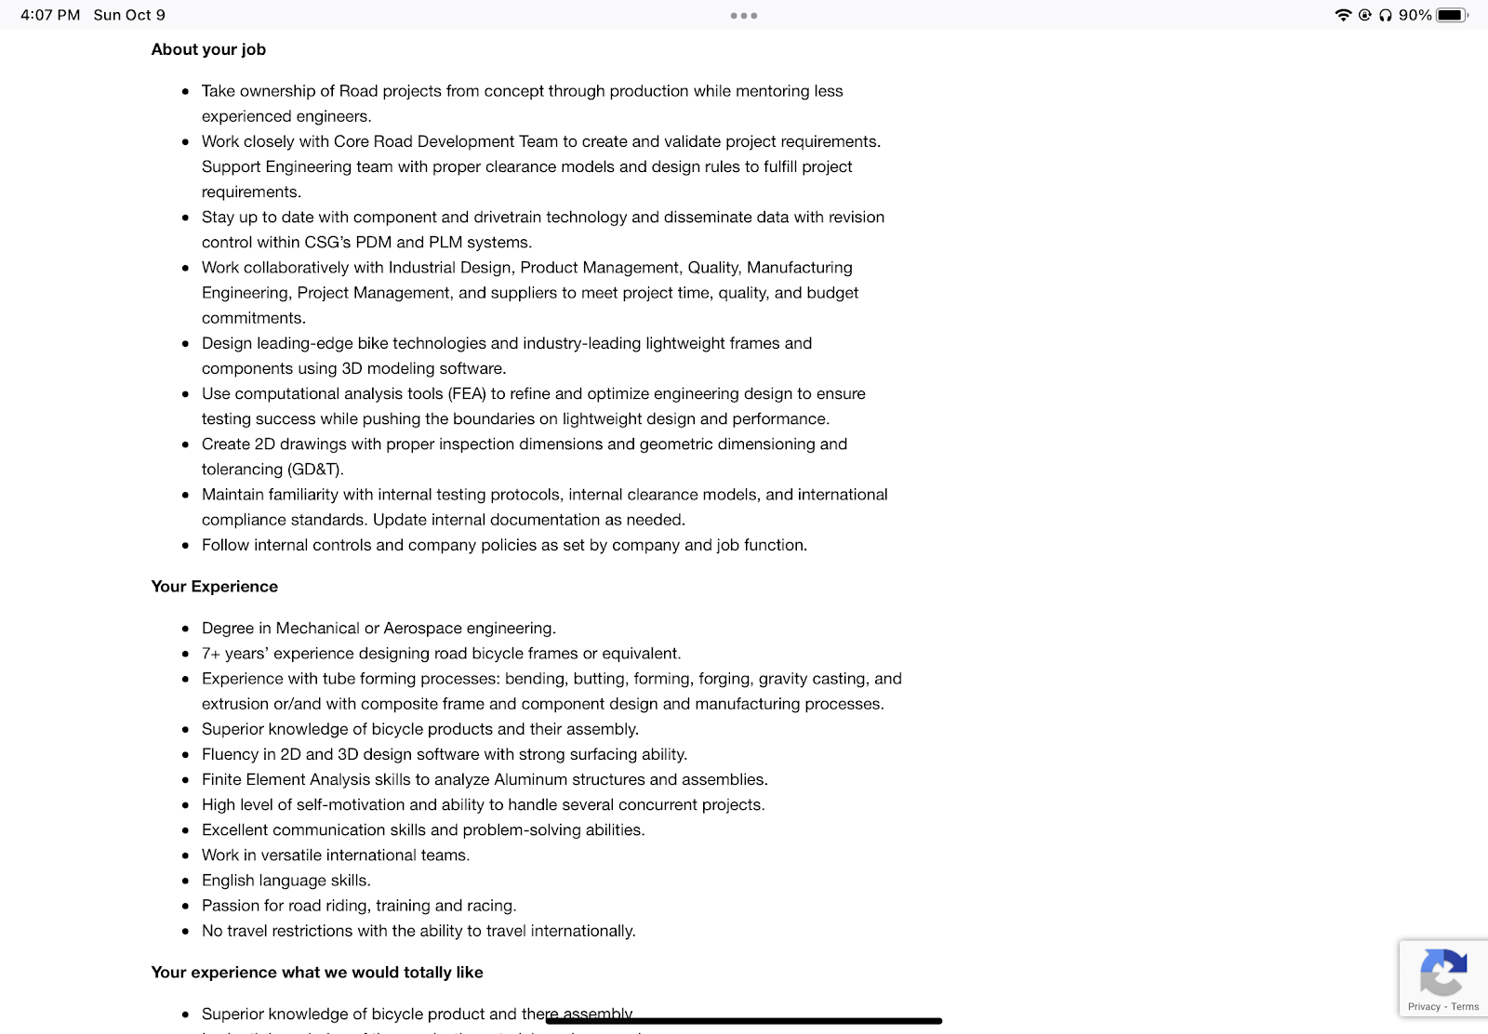

Reflection:
Work Design:
Engineering work will be done in person and at the warehouse workshop. The research and development will collaborate highly with other engineers and work teams. Communication with other affiliated parties could require the engineer to travel short distances to meet face-to-face. When you are trying to get feedback about a tangible product, it’s essential that both people can interact in person to gain a better understanding of the information. This face-to-face, two-way communication can go a long way in improving a product.

Sourcing Pools:
We are confident Concord, California, will have enough skilled employees in the area to run our business successfully. We will target people involved in the mountain boarding community since they have general knowledge of the sport and a large population in California. However, if we cannot find employees through traditional methods, we plan on using other methods to find candidates. In this case, we plan on reevaluating the job descriptions and hiring process to broaden our search. Another way we may use is returnship programs for people returning to work after a long period. This program would reach unskilled people in this area and help them gain experience in the field.

Recruiting Methods
Showcasing our products at club meetings and sponsoring competitions will be the primary mode of generating interest within the mountainboarding community. Although it isn’t the most popular sport, mountainboarding has a passionate community, so we believe it will make for good employees. We aren’t just looking for mountain boarders; our production engineer must be proficient in engineering. For this reason, we are also planning on using professional organizations to find qualified people to fill this role. Engineering is a highly skilled position therefore, we find it most likely that people qualified in this field are members of a professional organization. One proposed recruitment method would be to collaborate with a professional engineering organization and host a “learn to mountainboard” event for them. This would provide us with a group of both proficient engineering and fun-loving candidates. Depending on the success of our promotional strategies, we would also be willing to outsource our hiring process to a headhunter. This option would make sense for us since, in addition to engineering skills, the production engineer must be able to lead others and delegate work.

Fit:
We are seeking someone who fits firmly within the organization. By this, we mean that they have a passion for mountainboarding, are collaborative workers, and are active problem-solvers. Having a solid person-job fit is extremely important for a production engineer too. They must be able to understand the needs of our target markets and problem-solve to ensure that these needs are met. We want them to be able to work with a group of other qualified individuals to accomplish this goal. They should be able to participate in collaborative discussions and work to complete this job.

Assessing Fit:
Going through a list of preferred skills for the position the candidate possesses (both negotiable and non-negotiable).
Analyze the candidates personality type in order to determine if they would be a good fit with the culture of the company.
Asking about their interests and passions outside of work.

Questions to Help Determine Fit:
Tell me about a time when you had to juggle several projects at the same time. How did you organize your time? What was the result?
Is it better to submit a project that’s perfect and late, or one that’s good and on time?
Tell me about a time when you worked under either extremely close supervision or extremely loose supervision. How did you handle that?
You get off of work early at 3:30, what would you do with that free time?

Part 2
Context Reprise:
Basic Information:
Company name: Taranis Mountain Boards
Type: Manufacturing and Online Retail of Electric Skateboards
Location: Concord, California

What we do:
Taranis Mountain Boards is a manufacturing and online retailer selling a premium off-road electric skateboard with built-in suspension and a high-torque engine. This unique transportation device allows easy movement uphill at 50 degrees, 20 degrees higher than our closest competitors, Cycleagle and Radley.

Our Mission:
We want to manufacture premium mountain boarding equipment that makes the sport more accessible to the general population while improving the experience for current users.

How we will make money and compete:
We compete based on quality, differentiation, and customer service. Our mountainboards are the premium product on the market, with features that no other products have. While most traditional mountain boards are man-powered like a skateboard, Taranis makes battery-powered boards. Battery power allows riders to go up hills easily and extends the range of their adventure. We also offer a more comprehensive array of products than any other mountainboarding company, with a selection that ranges from expert boards to commuter boards for city transportation.

Industry: Manufacturing

Talent Development
Orientation:
Topics Included: Orientation will include a clear description of the mission of Taranis. There will be a tour of all the facilities that covers all staff introductions. There will be a brief description of what the customer service people do daily and the other staff. As a part of the onboarding experience, we will take all new employees out on a mountainboarding adventure. Participation is optional, which ensures that we don’t exclude heavier-set individuals, but attendance is mandatory. We will be sure to discuss the weekend retreats to resorts where employees can enjoy the product under its intended conditions. At the end of the day, we will encourage the engineer to take one of the boards home as their commute if the location allows.

Orientation Schedule: The owner will be the main point of contact on the orientation day, but people in different departments will take over for short periods to talk about their departments. Working directly with the owner for a lot of the day will accomplish a feeling of value for the new employee. Spending time in different departments will give them a feel for the culture and show how teams work in tandem. Orientation will be one full day focusing more on getting to know the facility and the people rather than the boards.

Training:
Skills Needed: The engineer will be assumed to know several things like how to use specific computer programs, read blueprints, and have a general knowledge of putting together products from blueprints. The training will mainly focus on the specifics of our product. The new engineer will spend time meticulously building and taking apart one of our boards to learn how it works. The engineer will also take training on cross-cultural team communication. Although the customer service/sales team and the design and engineering team work in close proximity, there may be differences in how the groups are run. Training on this topic will prepare for any discrepancies in communication styles between teams that need to communicate often. Project management training will be necessary when selling large orders of boards.

Methods of Training: Training for the intricacies of the mountain boards will be self-led training. Engineers are known for their need to understand how anything works. It will be prompted within the first days after orientation to sit with the board and dissect it, but it likely will not be necessary to encourage it. Training will take as long as the engineer sees fit to understand the product. Training for team communication will be outsourced to Dr. Phelps for a class-like setting. The training will take 2 days and will be used right away when customer service asks questions to engineers about products. The training will continue for at least 1 year, 2 days of training modules each month.

Performance Management:
What will we evaluate?
- How well the product is known to the engineer. Answers are provided within a short time and without struggle. Ability to take a board apart and put it back together.
- Quick Repair time.
How will we measure these?
- This can be measured by how satisfied the customer service department is with the answer speed of questions to the engineer. We will also evaluate through a game like setting of “who can put take it apart and put it back together the fastest?”.
- This will be measured in the amount of time it takes from when we receive a board for repair and when it is shipped out.
Who should provide input for the evaluation?
- Everybody in the company should provide input. With it being a fun competition everyone can report their feedback in their cheers of victory or woes of defeat. Specifically, coworkers, customers, and self-reflection will be used to evaluate performance.
- Customers should provide input to this. Much of the strategy is on quality and customer service, so if the customers are dissatisfied with the speed of service they should let the company know.
How often should these employees be evaluated?
- For this evaluation, there should not be any formal evaluation. It should be taken as a guide to whether or not the engineer knows the product. Once a month the owner will set up a competition and also compete in it. The employees will not know that this is an evaluation, but it will also not affect them as the main form of evaluation.
- This evaluation will come in real time of the customer receiving their repaired board and writing about their satisfaction or dissatisfaction with the speed and product.

Total Rewards:
Base Compensation: Based on our location and the difficulty level of the task we ask our employees to accomplish, the salary we will offer them is $100,000. This number is based on not only comparing to others with the same type of position in our area but also adjusted based on the tasks we require our employees to do. After one year of being employed for us, we will then reevaluate our pay levels to ensure that they stay competitive and that our employees know that we care about the quality of work they provide and are compensated accordingly. After that first reevaluation, we will continue to reevaluate every six months for the employees' time at our company. This does NOT mean that every reevaluation will lead to an immediate raise, it will be documented and based on the specific employees performance, we will go from there.

Incentive Pay: We would use incentive pay to motivate employees to work overtime. During weeks when they log over 40 hours, employees will be paid 1% commission. Incentive pay is not standard in our industry however, it is not unheard of either.

Benefits: When considering benefits that are not monetary, we envision the environment we must create in order to retain our employees. One thing we are going to put a lot of effort into, when going through the hiring process, is finding employees that are genuinely interested in the product we are making. By hiring people that care about the product on their own we aim to create an environment where not only our employees push the boundary of what we make but also, feel comfortable around other employees. Liking your coworkers is an intangible benefit that outweighs monetary benefits in many cases. In addition to a cohesive environment, our other non-monetary benefits include;
- Healthcare plan
- Flex time Friday’s
- 3 month maternity leave
- Casual dress code
- Employee lounge with kitchen and TV
- Membership to gym across the street

High Performance Work Systems:
Engaging Onboarding Process:
The standard onboarding process involves a tour, description of your responsibilities, and getting introduced to your coworkers. While we will be doing all of these, the manner in which we approach them will be slightly different. After completing the tour of the facilities, employees will go to a local favorite mountainboarding spot. This creates a natural situation for the new employees to meet their coworkers, and is a way for them to get a sense of the company culture. During this trip, they will likely meet local mountainboarders, giving them a chance to get a sense of the sport’s culture and bring them closer to the customer.

Selective Hiring:
Taranis has a long term vision, where we hope to become the leading company for all things mountain boarding. This vision will only work if we are selective in the hiring process, choosing technically qualified people with knowledge of the sport. Selective hiring will improve retention, engagement, and the product itself. Our hiring process will have to be different from most other companies. We cannot just hire people who got a degree from a good university, we need people who are committed to creating a leading brand in a sport. It’s unlikely that we will find these candidates on sites like Indeed, so we will have to seek them out. Finding pools of candidates who are interested in mountain boarding is just as important to us as finding candidates who are exceptional engineers. A good engineer will always have job offers, but if they have a firm person-organization fit, it will be more difficult to pry them away. And an engineer who has no experience with a product cannot possibly be aware of the needs of everyday users.

Employee Security:
We will guarantee employment at least one year after being hired, contingent on completing training modules each month. Policies that aim at keeping employees around long-term improve their sense of job security. This will also make our selective hiring process even more important. If we are going to guarantee employment for a certain amount of time, they better be a near-perfect fit.

Reduced Status Barriers:
The sooner people get the information they need to do their jobs, the better. For this reason, each employee will be given their direct manager’s phone number and the owner’s. Communication cannot be expected from employees if the bosses don’t make themselves immediately available. Doing this is a way to show employees that you trust them to respect your time and privacy and that their position is important enough to warrant direct communication with the owner. Mountain boarding is a sport that has yet to break out into the mainstream, and our wide product selection makes it more likely that one of our variations will catch the public's attention. For this reason, we need to stay agile. Agility requires communication, though. If one of our products is reviewed in a viral Tik Tok and we get 2,500 orders within a week, we have to be able to shift production to accommodate the volume. We would also want to focus our sales efforts on this model and begin researching ways to improve it, which would require more engineers, laborers, product testers, salesmen, and accountants. With a direct line of communication, the news that one of our products is becoming popular would be given to ownership as soon as possible. This would enable them to quickly order more supplies, prepare the manufacturing team to increase production, and prepare new sales strategies.

Sources
“51-0000 Production Occupations (Major Group).” U.S. Bureau of Labor Statistics, U.S. Bureau of Labor Statistics, 31 Mar. 2021, https://www.bls.gov/oes/2020/may/oes510000.htm.

“California Wages: 17-2071.00 - Electrical Engineers.” O*NET OnLine, https://www.onetonline.org/link/localwages/17-2071.00?st=CA.

“California.” U.S. Bureau of Labor Statistics, U.S. Bureau of Labor Statistics, https://www.bls.gov/regions/west/california.htm.

“North American Industry Classification System - NAICS.” United States Census Bureau, https://www.census.gov/naics/.

“Professional Engineer Pe. (Electrical).” The CBR Group, https://www.thecbrgroup.com/professional-engineer-pe-electrical.

“Senior Design Engineer - Road.” Job Application for Senior Design Engineer - Road at Cannondale, https://boards.greenhouse.io/cannondale/jobs/4633397004.

