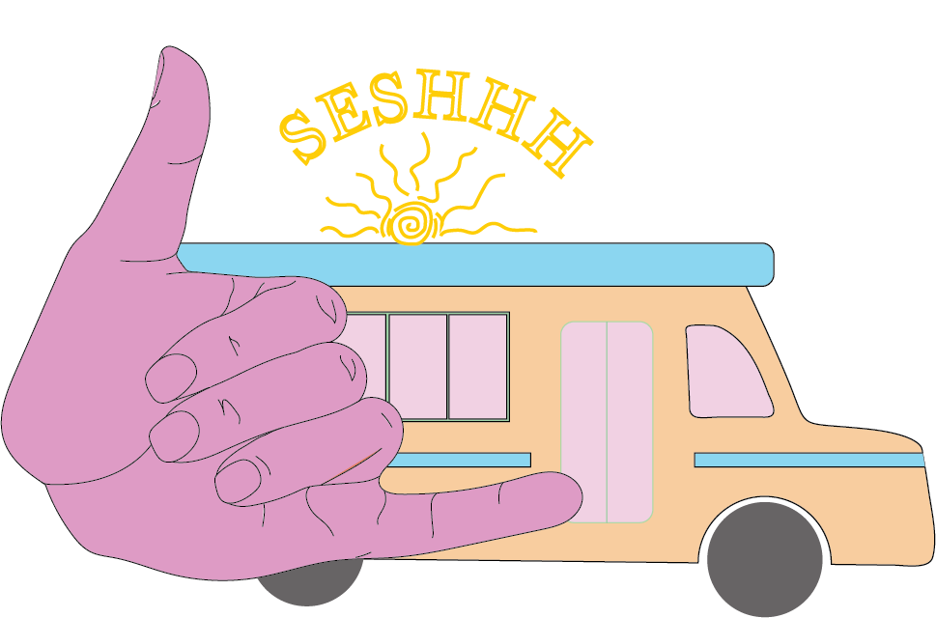

“THAT WAS A SESH”

Business Plan by Jackson Momm-White & Christopher Mood
May 2020

Executive Summary:
Seshhh is a mobile surf lesson and surf rental service which operates throughout coastal New England. Seshhh will provide wetsuit rental, surf board rental, and private lessons. We will provide our service out of a Ford E-350 short bus which serves as a mobile store front and houses our inventory. Additionally Seshhh understands that being socially conscious is an awesome way to build community support, which is why we will be also hosting events like a beach cleanup to help keep our beaches clean. Our mission is to spread a passion for surfing in coastal communities by providing a unique surf lesson experience as well as equipment rentals at a fair price.
Seshhh aims to reinvent the traditional surf lesson and rental experience, which can often be inconvenient and very expensive for families. The most glaring issue that we noticed about the way surf lessons are done are the group sizes, at some local surf shops where group sizes can spiral out of control there can be up to twenty people in a group. When lesson sizes get this big, they can become unsafe and there is no individual attention given to each customer. Seshhh provides the best way to keep student to instructor ratios low because we cap the group lesson size at five. The second issue that we noticed was the price of lessons; the price of private lessons ranged from $65-$105 per person, making it unaffordable for many families to let their kids try surfing, which is why Seshhh is committed to keeping lessons affordable for the average beachgoer. These factors weigh heavily on the average beachgoer and tend to make people hesitant when it comes to getting their feet wet in the world of surfing.
Throughout our first season, Seshhh will market our services to tourists, and locals living in Rockingham County NH, Essex County MA, and York County ME with the hopes of spreading awareness of our company. Local families in particular will be vital to maintaining our revenue throughout the slower less touristy months. Out of state tourists will help increase our cash flow as the summer progresses, as thousands of them come into coastal New England every year for unique outdoor experiences.

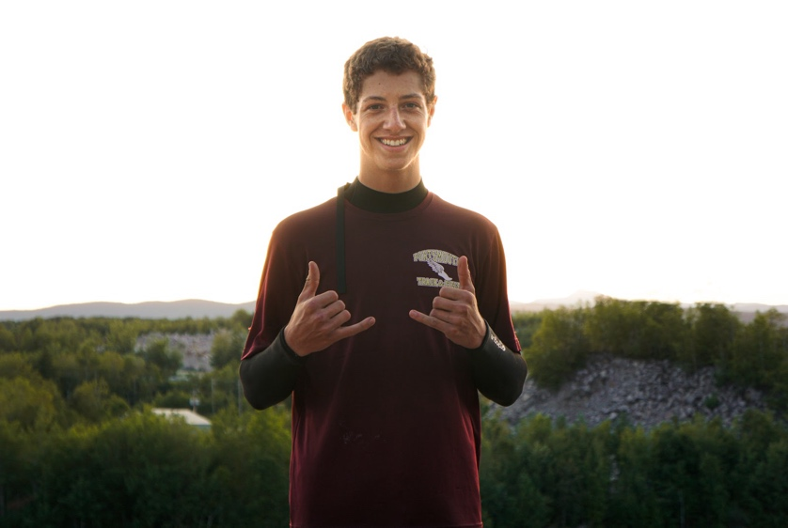
Management Team:
Christopher Mood: Co-Founder
I am an 18 year old business student at Portsmouth High School. Throughout my life, I've lived in various areas of the New Hampshire seacoast, however, I currently live in Portsmouth NH with my mother and sister. My hobbies include track and field, skiing, freestyle cliff diving, and surfing. Ever since I can remember, I’ve had a love for helping others as well as an equal love for the outdoors. At a young age, I started mowing lawns over the summer breaks for my neighbors; my mini-business was called Moods Mowing. For about three years, I cut grass, until my first job at Golf & Ski Warehouse as a fourteen year-old sales representative. This was where I got a real taste of what the business world had to offer. Since then my passion for business has grown and has helped pave the way to where I am today.
After I graduate from Portsmouth High School, I plan to continue learning about the business world at The University of New Hampshire’s Peter T. Paul School of Business in the fall.


Jackson Momm-White: Co-Founder
I am a senior at Portsmouth High School where I am enrolled in advanced college prep classes and multiple college-level classes through the Running Start program. I am involved in the Business Club, the Sales Club, as well as both the indoor and outdoor varsity track team. I've worked in the hospitality industry for three years teaching ski lessons and working at local restaurants. I have always had a love for the outdoors, most of my childhood was spent in the White mountains of New Hampshire. Over the past two years I discovered an ever-growing passion for surfing, and a desire to share this passion with others. After my high school career concludes, I will be going to Roger Williams University to study Business Management while sharing my passion for surfing with others during the summers through Seshhh.

Table of Contents

Executive Summary……………………………………………………………………………….1
Management Team………………………………………………………………………………...2
Competitive Analysis……………………………………………………………...………………4
Direct Competition………………………………………………………………………………...7
Industry Analysis………………………………………………………………………………….9
Outdoor Recreation………………………………………………………………………………10
Service Description…………………………………………………………………………..…..11
Services Uniqueness……………………………………………………………………………..12
Market Segmentation………………………………………………………………………….…14
Marketing Plan…………………………………………………………………………………...15
Pricing Strategy …………………………………………………………………………..……...15
Promotional Strategy………………………………………………………………..…………...16
Operational Analysis……………………………………………………………………………..17
Growth Plan……………………………………………………………………………………...19
Contingency Plan………………………………………………………………………………...20
Financials…………………………………………………………………………………....…...21

Appendix A……………………………………………………………………………………….23
Appendix B………………………………………………………………………………………25

Competitive Analysis:
Seshhh prides itself on providing private or public surf lessons at a variety of local beaches on the East Coast, while keeping the price below competitors. Through research, we’ve concluded that our price is more than half that of competing surf shops. The mission of Seshhh is to spread a passion for surfing to coastal communities by offering surfboard rentals and quality surf lessons at a fair price. Almost all other companies operate out of a building, meaning that they are limited to one location, however, Seshhh will operate from a mobile van bringing lessons to those who may not be close to a surf shop. The mobility of our van vastly expands where the service can be provided.

Value Proposition:
Seshhh provides mobile surf lessons and board rentals to the communities of coastal New England. We are committed to providing affordable and informative lessons to surfers of all ages, mobility allows Seshhh to come to the buyer instead of the buyers coming to us creating a convenient experience.

Barriers to Entry:
The New Hampshire surf lesson business has two primary competitors, Summer Sessions, and Cinnamon Rainbows, both of these shops have fairly strong customer loyalty due to their good reputation in the surf community which could make it tough for a new business to attract their customers and break into the local market. Another possible barrier is the high overhead costs that come with buying a van and supplies such as surfboards, fins, wetsuits, and leashes, which we will need for the lessons. Lastly, building trust and brand recognition in the community is always tough when an unestablished company begins offering a service to the community.

 | Location | Board Rentals | Wetsuit Rental | Lessons
Summer Sessions | Rye, NH | $25 HD  $35 FD | $15 HD  $20 FD | $60 public  $65 Private
Cinnamon Rainbows | Hampton, NH | $25 HD  $35 FD | $15 HD  $20 FD | $55 public  $65 private
Liquid Dreams | Ogunquit, ME | $20 HD  $30 FD | $10 HD  $15 FD | $70 public  $105 private
Black Point | Scarborough, ME | $15 HD  $25 FD | $10 HD  $15 FD | $50 public  $80 private
Seshhh | Mobile | $10 first hour  $5 every following hour  $30 full day | $5 HD  $10 FD | $30 (1 hour)  $45 (2 hour)

Comparative Analysis:
 | Waterfront Location | Rental Surfboards | Lessons Under $40 | Mobile
 | 



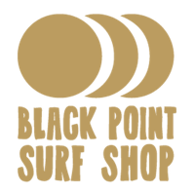

Direct Competition:
Summer Sessions: Summer sessions has a strong following in the local surf community due to their waterfront location, large surf shop, and healthy snack shack. They have been providing lessons and rental services for a very long time and grew into a household name for local families. They offer Surfboard rentals daily at $25.00 dollars for half day rentals as well as $35.00 full day rentals. For wetsuits they charge $15.00 half days and $20.00 full day rentals. Summer Sessions also offer bundle deals on boards and wetsuits rentals. For a half day of rentals that includes wetsuits and surfboards they charge $35.00 and for a full day of rentals they charge $40.00. All Summer Sessions surf lessons are an hour long and the lessons can be in a group or private. They teach lessons daily from 10am-5pm for standard lessons, private lessons must be reserved in advance. For the rate of $60.00 surfers can learn the fundamentals in a public lesson, For $65.00 surfers can get a private lesson. Summer Sessions also teaches stand up paddle board lessons.

Cinnamon Rainbows: Cinnamon Rainbows is another very popular shop in the area. They offer private, one-on-one, and group lessons, as well as all day (over 4 hours) and half day (4 hours or less) board and wetsuit rentals. They have built a strong following due to their large surf shop and their convenient location in a popular tourist area. Cinnamon Rainbows’ surf lessons must be scheduled in advance which makes it less convenient for a spur of the moment decision to purchase lessons. Their group lessons are $55 for an hour and are available to people older than 11. Their private lessons are $65 but are available to people of all ages. On Mondays, Wednesdays, and Fridays, they organize an hour and a half kids group lesson for $25 and an additional $10 if they need equipment. On Tuesdays, they offer a novice adult surf camp, and on Thursdays, they have a women's camp. Both of these are the same price as the kids camp.

Liquid Dreams: Liquid Dreams Surf shop is a well-known hangout for surfers on the southern coast of Maine. Its first location opened in the spring of 1996 in Ogunquit. Now with two locations in York and Ogunquit, they control the region’s surf market by providing surf lessons as well as rentals. Liquid Dreams rents out surfboards daily for $20.00 for half days as well as $30.00 for a full day of board rentals. The surf shop rents out wetsuits at $10.00 for a half-day and $15.00 for a full day. In addition, the company offers standup paddleboard rentals and kayak rentals. Their public surf lessons happen at two different times in the day, an 8 am-10 am lesson or a 5 pm-7 pm lesson at their York location. The Ogunquit locations offer the same lessons from 10 am-12 am and 3 pm-5 pm. For $70, a rider is taught the fundamentals of surfing. LDS provides 2-hour private surf lessons for $105.00 to work with students individually or with a friend.

Black Point: Black Point surf shop is one of the newer surf shops on the East Coast. They opened in 2011 near Higgins Beach in Scarborough, Maine. They provide 90-minute lessons for both groups and individuals. They have lessons for both beginners and more experienced surfers who want to improve their skills. In Black Point’s rental shop, they offer 24-hour board and wetsuit rentals. A unique feature that they offer is weekly rentals, where the renter can keep the board/wetsuit for 7 days. A renter can choose between renting a soft-top surfboard and a fiberglass surfboard. Black Point sells custom surfboards which are designed and crafted below their store, in the crafting space they also repair surfboards. (graphic shown in Appendix B)

Industry Analysis:
Seshhh will enter the Service Industry as part of the New Hampshire Tourism sector. Tourism is New Hampshire's second-largest industry generating more than $5 billion of economic activity per year in the state. This industry gives over 70,000 people jobs all throughout the state. New Hampshire has traditionally depended on its natural resources and recreational opportunities to draw in out of state visitors throughout the year. The Seacoast, Lakes Region, and the White Mountains are the primary destinations for tourists.
While the state keeps records of day-trippers and overnight guests, a less-studied aspect of New Hampshire’s tourism economy is its popularity as a site for second homes. Many of the state’s vacation homes are owned by people who live out of state and visit communities for several weeks or months at a time, in that time, they pump money into communities. The flip-side of this deal, however, is that in a community’s off-season, service work can become scarce as the town empties out. International tourists could also be possible customers, In 2016 New Hampshire was visited by 414,000 international travelers, these tourists spent nearly $227 million traveling in New Hampshire.
Well-known businesses who take advantage of the tourist season include Summer Sessions and Cinnamon Rainbows, in short, both sell retail, surfboard sales, surfboard rentals, and lessons. The New Hampshire seacoast has a tourism industry that has been growing constantly from 2015.
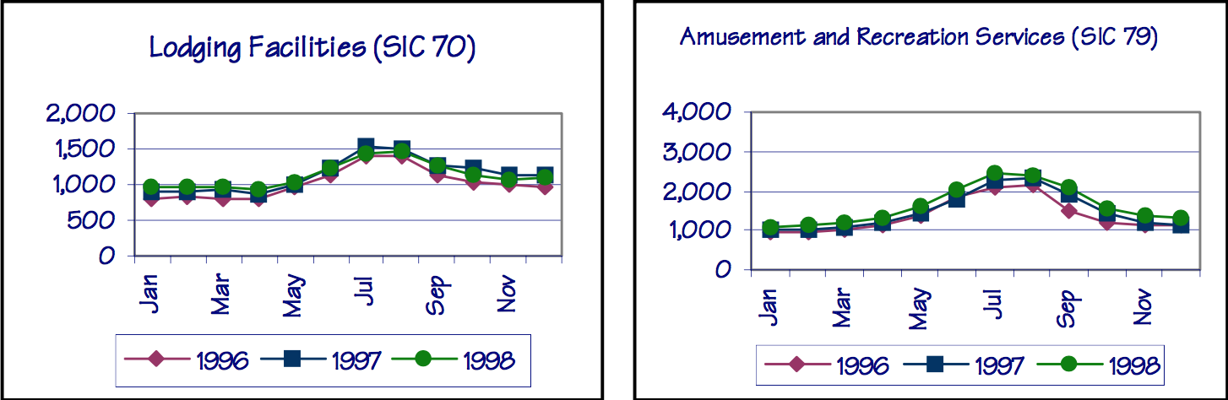
Outdoor Recreation:
New Hampshire is creating the Office of Outdoor Recreation Industry Development dedicated to outdoor recreation in hopes of both expanding that industry and using it to attract young workers to other sectors. The new office will be part of the state Department of Business and Economic Affairs and will promote New Hampshire as the East Coast state that best combines a vibrant economy with outdoor lifestyles. Currently, the state's outdoor industry employs about 79,000 people and generates $8.7 billion in consumer spending annually, according to the Outdoor Industry Association.
According to a report by VisitNH.gov, 69 percent of New Hampshire residents participate in outdoor recreation each year and are more likely to participate in day hiking and kayaking than the average American. The same report says, more jobs in New Hampshire depend on outdoor recreation than ever before, the number of jobs that depend on outdoor recreation reached 79,000 last year. Employees working in outdoor recreation jobs earned $2.6 billion in wages and salaries.
History:
The origins of surfing date back around 5000 years, but the modern form of surfing that we know today was first documented only 300 years ago by Joseph Banks. Surfing began to become popularized in the early 1900s by a Hawiian man by the name of Duke Kahanamoku, who introduced the sport to Australia and pushed for it to become an Olympic sport. In 1950 the first retail surf shop was opened. In the following decades, the industry exploded along with the popularity of the sport. By the 1970s surfing had been validated as a sport by the mainstream media and gained extreme notoriety, surf shops now lined the coasts all the way from California to New Jersey. As the sport continued to grow, smaller surf shops began to turn their attention from retail to teaching lessons because they noticed the growing number of people who had the desire to surf but didnt know how. Around the same time that surf lessons became popular, many shops began to offer wetsuit and surfboard rentals for those who didn't want to financially commit to the sport.
Service Description:
Seshhh:
is a mobile surf company that provides surf lessons and surfboard rentals. We will be operating out of a van converted to specifications that allow for equipment storage as well as a workspace and living area. Our van will move up and down the East Coast making frequent stops at public beaches where we will offer beachgoers to get lessons on how to surf. Soft Top surfboards will be available to rent through our services. Seshhh stresses the importance of teaching in small groups of surfers because it ensures that everyone can learn as much as possible from an hour-long lesson.

Service Uniqueness:

Lessons:
Seshhh is different from most other shops because we are committed to providing individual attention to customers and detailed lessons based on each rider's ability and style. A novice surfer will not learn much from a lesson if they are in a large group of other surfers, which is why it is essential for a teacher to give specific instruction to every individual in the group instead of basic directions to a huge group.

Rentals:
Even if a customer decides to not purchase lessons, Seshhh will provide wetsuits and Soft Top surfboard rentals. Soft Top surfboards are less expensive for us to buy, are extremely durable, and are much more buoyant than fiberglass surfboards, which makes it easier for novice surfers to learn how to surf. Because the soft top boards are less expensive, we will be able to lease them out for a fraction of the price of the local competitors. Unlike our competitors, Seshhh rents out surfboards for $10 for the first hour and $5 for every following hour so that an individual can try surfing for however long they want, without feeling the commitment of a full day or half day rental.

Mobility:
Seshhh will be using a modified short bus as a mobile storefront, which will allow us to travel to beaches all along the East Coast. It's convenience to the public is what sets it apart from other companies, Seshhh will set up shop in parking lots right next to the beach making the rental or lesso experience as convenient for the buyer as possible. The van will travel to public beaches and set up shop for the day-sunrise to sundown-enabling the general public to take lessons as well as rent out surfboards and wetsuits for the day.

Affordability:
One of the benefits of operating out of a van with a small staff is that Seshhh doesn't have the same expenses that many other companies have, such as paying employees or rent. These eliminated expenses allow us to offer the service for a fraction of what the competitors charge while still offering a high quality lesson or rental experience.

Hours: Monday through Sunday 6:30-7:30, 8:00am-8:00pm
Board Pricing: $10 first hour, then $5 per hour after that or $30 whole day.
Wetsuit pricing: $10 down payment for the whole day, 5$ after 2 pm.
Lessons: $30 for 1 hour lesson, $15 for every hour after that. wetsuit and board included; additional $10 to keep board and wetsuit for remainder of day
4 person maximum with an exception for immediate family
Market Segmentation:

Target Market:
Seshhh will mainly be trying to attract out-of-state and international middle-class families who will be visiting the coasts of New England as well as local families who are visiting the beach for the day. We think that tourists coming from other areas of the North East will be our main customers because they most likely don't have access to surfing in their hometown. Tourists who are visiting coastal New England are mostly visiting with the intention of spending time at the beach. Since Seshhh makes surfing very accessible and inexpensive for people to try, we believe that many inexperienced surfers from all over will decide to try it out. According to VisitNH.gov 48% of tourists were visiting New Hampshire for either “kids and fun” or “outdoors'' and 62% of tourists were motivated to visit New Hampshire to be “Being amazed by the sites or experiences'' or “Thrills and excitement”. Based on these statistics it's clear that the families visiting New Hampshire want to have unique experiences and participate in outdoor activities.
We also believe that local families will play an important role in our bottom-line, other companies like Summer sessions and Cinnamon rainbows have built a strong following with locals and rely on their business which makes us believe that locals will also be interested in Seshhh. With think that people who are active in the community will play a key role when it comes to the events that we host such as Surf & Sweep, (our beach clean up) as well as helping bring in revenue during periods where there is poor weather or few tourists.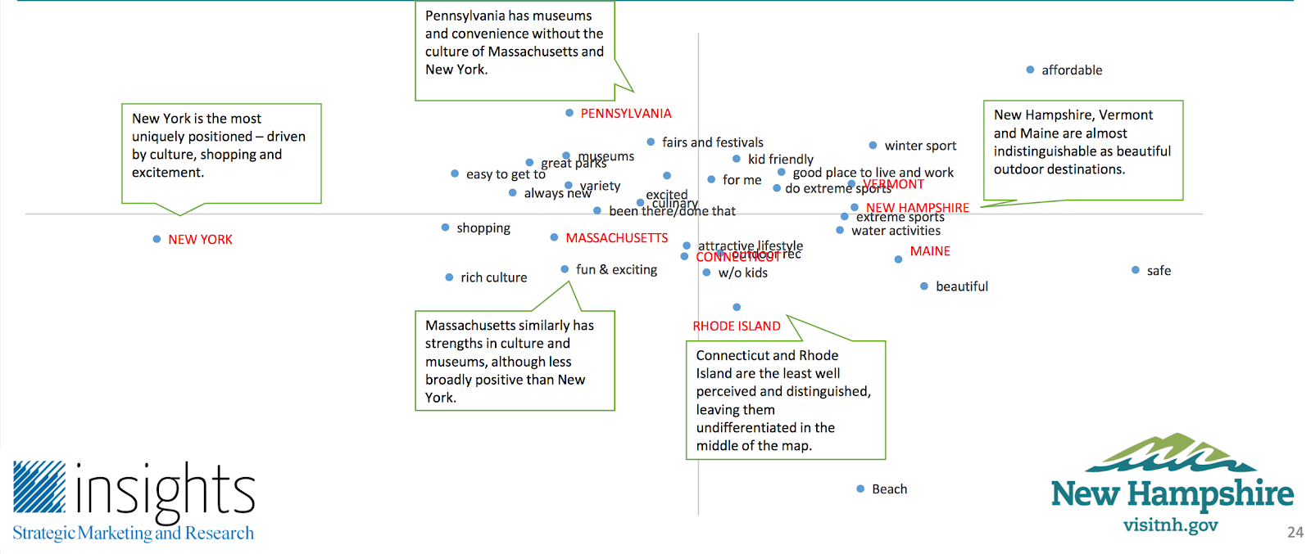
Marketing plan:
Seshhh intends on marketing through placing ads on Youtube and Instagram to better reach our target market as well as tap into the local market place. Our main way of attracting customers will be meeting people who are already at the beach, so we are going to wrap our bus, making it an advertisement that goes wherever we do and instantly attracts and informs potential customers. On top of that, we hope to build connections with local hotels and tourism businesses with the idea that our name will be on the brochures in their lobby and recommended by their concierge services. In our Youtube ads we want to show people beaches where we will be showing up to teach lessons and telling them a little bit about the company, such as; who we are, what our website is, and our prices for lessons and rentals.

Pricing strategy:
Our pricing strategy is to try to make our prices much lower than all of our local competitors, we will be positioning ourselves in the market as a high quality and inexpensive option. We are able to do this because we don't have as many expenses as most companies, such as rent, or the cost of labor. We feel that having low prices will be the best way to break into the marketplace, especially when tourists come looking for the best deal. With our low prices and our prime positioning, we think that our service will fall into the customers hand.

Promotional Strategy:
We will promote Seshhh in four ways
- Youtube ads: A short 30 second Youtube advertisement will be a key part of our advertising. We believe a quick video advertisement is a great way to reach our target market. We expect to spend roughly $550 advertising this way for the first season. The video will broadcast to those living on the Eastern coast of the United State and to those who have an interest in the sport. Secondly the ad will show video of the van itself as well as the days and times our van will be in a certain area. When anyone clicks on our advertisement it will redirect them to our Facebook page where they can see all of our scheduled locations.
- Instagram ads: We think that Instagram ads are a good way to reach out to our target market at a low price. We will spend roughly $200 on these ads in preparation for our first open season. In these ads we’ll show a picture of our van so people know what to look for, on our van it will show a schedule of where we will be on certain dates. Another ad will show a picture of our logo and a statement of who we are and what we do.
- Wrapping our van: Wrapping our van will be one of the most crucial ways to spread our message. The van needs to be a mobile advertisement for our company and a magnet for tourists at the beach. We have a couple ideas for how to make our van unique, instantly recognizable, and informative. On one side of the bus we want to have a section where our customers get to put stickers with their name and our company logo on it, which would help spread our brand. On another section of the van we want to have a large print of our logo with our company name above it. On the back of the van, we thought it would be smart to have our schedule so people will know when and where to find us.
- Partner with local businesses: We plan on partnering with local businesses and organizations such as hotels and the chambers of commerce, who will help advertise for us by telling tourists about our business. We would also like to partner with local restaurants by doing a “surf and sip” where a group could go out surfing followed by a meal at a local restaurant.

Operational Analysis:
The Seshhh van is the most crucial element of our company, it will serve as a mobile advertisement, our home for the summers, and a storage unit for all of our equipment. We are equipping the van with two beds as well as a small living quarters so we can always be on the move. The van will be split in half, one side will house our surfboard and wetsuit inventory, while the other half will serve as both our living space and point of sale. Eventually, the van will move far up and down the east coast, but first we plan to start small by focusing on a select few communities in New England. While we’re working on the coast of New Hampshire, Maine, and Massachusetts, we hope to hope to engage customers, build a strong reputation and begin to grow our brand familiarity.
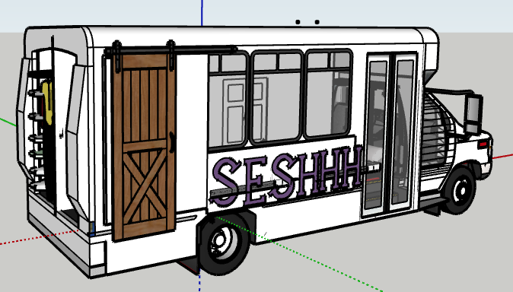
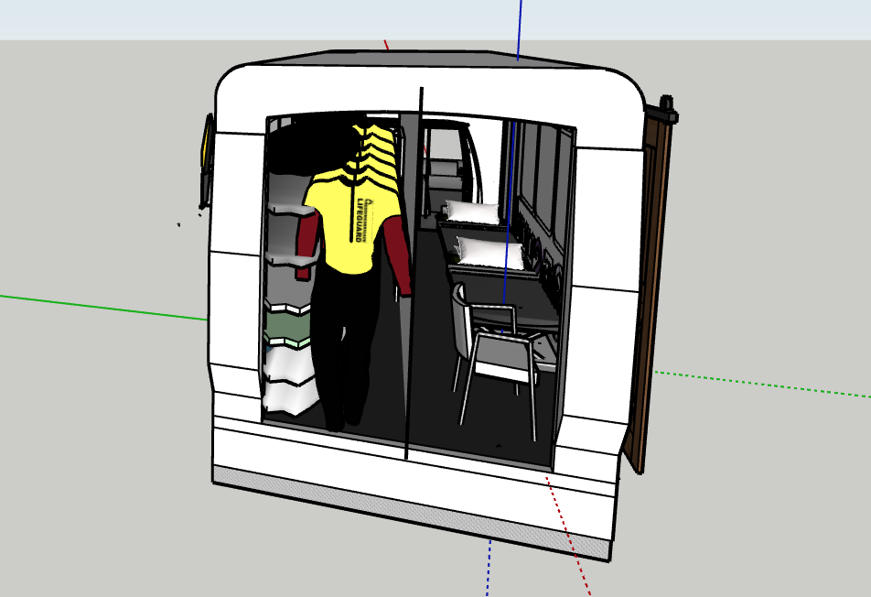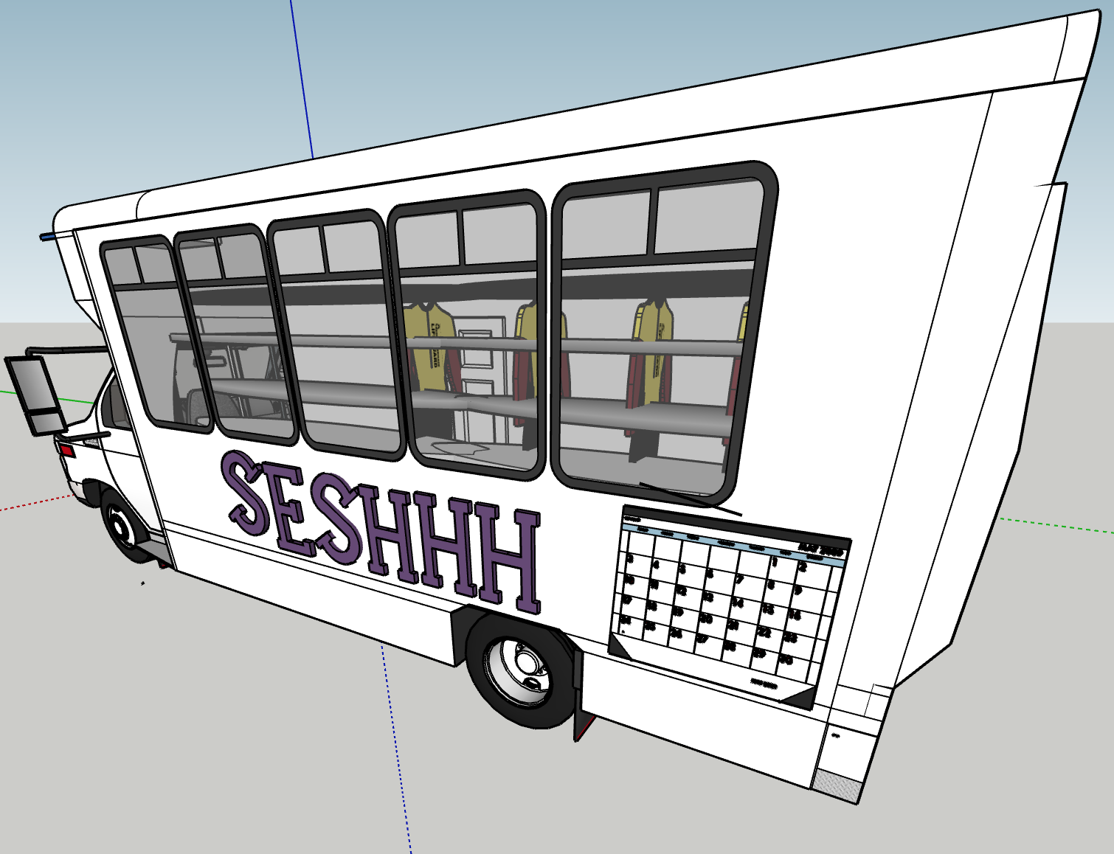
Growth Plan:
Our goal is to put our growth plan into effect shortly after completing college. During college we will be focusing on learning more about the market place and developing our services.
(Our growth plan will be implemented through two different ways.)
- Market Penetration - This strategy includes implementing our low pricing. Due to our low expenses we’re able to keep prices low which will allow us to include people in the sport who don't usually get to give it a try. On top of that, regularly we will be hosting beach cleanups for local communities called Surf & Sweep where people who pick up trash will get free rental vouchers and stickers.
This strategy will also include a rewards program with discounts and events for recurring customers. Recurring customers can refer a friend and get discounts for both parties. The Seshhh Rewards program will offer loyalty point accumulation which can add up to a free surf lesson or rental. In order to prevent overbooking with lessons during our seasonal business, we will be implementing the program earlier in our timeline (potentially during the summer of our junior year). This way we can avoid damaging the quality of our lessons as well as the rest of our service.
- Product Development - Another plan we will move forward with is offering a new service. Following the completion of college we will start spending all of our time on the development of our business. After overseeing operations for three summers, we will explore new ways to make packages and benefits for our customers. As well as partnering up with other local businesses to host events such as a beach clean up. One of these new services we hope to provide would be Surf and Sip. Surf and Sip would be an event sponsored by Seshhh and a local bar or restaurant where people can surf at a discounted rate as well as eat or drink after at a restaurant for a similar deal. Down the road adding another location in a more southern area to cover more ground.

Contingency plan:

External Risk:
Market Risk: Lack of Customer Awareness
Alternate Courses of Action | Advantages | Disadvantages
Do nothing: continue with a smaller customer base and focus on good service | Focus on better service  Build loyal customer base | Slow growth, if any
Increase Marketing | Merge into market quickly  Increased customer base | Time  Complicated Logistics
Partner with well-known local Surf Shop | Allow for more customers  Less overbooking  More equipment | Payroll increase  Training required  Quality may decline

Internal Risk:
Wrong Target Market: Locals vs Tourists
Alternate Courses of Action | Advantages | Disadvantages
Do nothing | No change required | Potential decrease in market share
Begin marketing heavily to locals instead of tourists | Build a loyal following with local customers, meaning more repeat customers | Lack of out of state awareness  Slower growth
Begin marketing heavily to tourists instead of locals | More customer awareness  Quicker growth | Fewer repeat/local customers
Financials:
Before we could even begin to put together sales projections, we first had to decide on how many days we would be open and what our hours of operation will be. Our first year being open, Seshhh will be open from June 1st-September 1st (92 days). We estimated that about 22 of those days we will not be able to open because of bad weather, bad surfing conditions, or other miscellaneous reasons, leaving us with roughly 70 days to offer rentals and lessons. The next step was to decide on our hours of operation, we decided that Seshhh will be open from 8 am-8 pm meaning that we will be open for 12 hours a day.
The next step of the projection process was to come up with rental sales and lesson revenue for an average day. For surfboard rentals we projected that 20 surfboards would be rented for the whole day, another 20 would be rented for an average of 2 hours in the morning, once they are returned, we think that 10 of those boards will be re-rented in the afternoon if these averages hold true than our daily surfboard rental sales will be roughly $1200. We assumed that most people who rented surfboards would also rent wetsuits, but we figured that a small number of people that rented boards wouldn't rent a wetsuit as well, therefore, when we calculated the wetsuit sales we thought that it would be 5 less than the surfboard rental number, with these numbers our daily wetsuit rental revenue would be $300.
After we figured out our total rental revenue, the next step was to find how much revenue teaching lessons would bring in. We thought that a conservative approach to these projections would give us the most accurate sense of what an average day would look like. We figured that we could teach 7 groups in the 12 hours that we are open on average, of those 7 groups we think that two of them would decide to add on a second hour. Of the 7 groups we think that on average, 3 of them would decide to keep the surfboard and wetsuit for the rest of the day. If we assume that on average a group has only 3 people in it, then our total daily revenue for lessons would be roughly $1080.
Now that we figured out our average daily revenue, we wanted to figure out what our seasonal revenue could be, so we added the total rental revenue ($1500) and the lesson revenue ($1080) giving us a total of $2580. We multiplied our total revenue by the number of days we think Seshhh will be open (70 days) giving us a total seasonal revenue of $180,600.

Funding: Our funding plan begins with each of us putting up $5,000 of our own money, making us 50/50 partners in the business. This money will be used to buy essential equipment like surfboards and wetsuits. Seshhh will still need $25,000 to open, the most reasonable course of action is for us to get a loan. A loan makes sense for our business because it will supply us with the funding that will allow us to buy a short bus and convert it. With the combination of our raised funds and the loan, we will have enough capital and the proper equipment, enabling us to open our doors. Based on our sales projections, we should break even on the investment relatively quickly, meaning that we would be able to pay the loan back without too much trouble.

Appendix A
Financial Statements Included
Year 1-3 Financial Breakdown
Year One Start Up Expenses
Year 1-3 Cash Flow
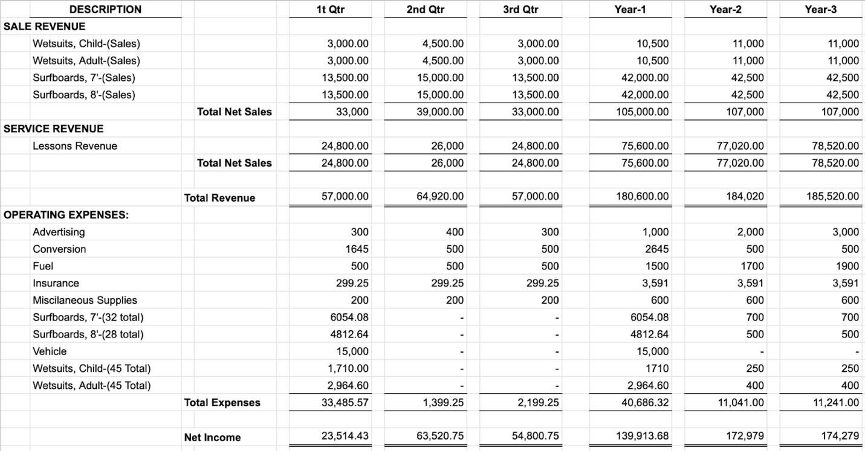
Appendix B
FIFE & ALLKANE Insurance Quotes
Business Auto Annual Fee
Business Owners Quote

Business Auto Annual Premium: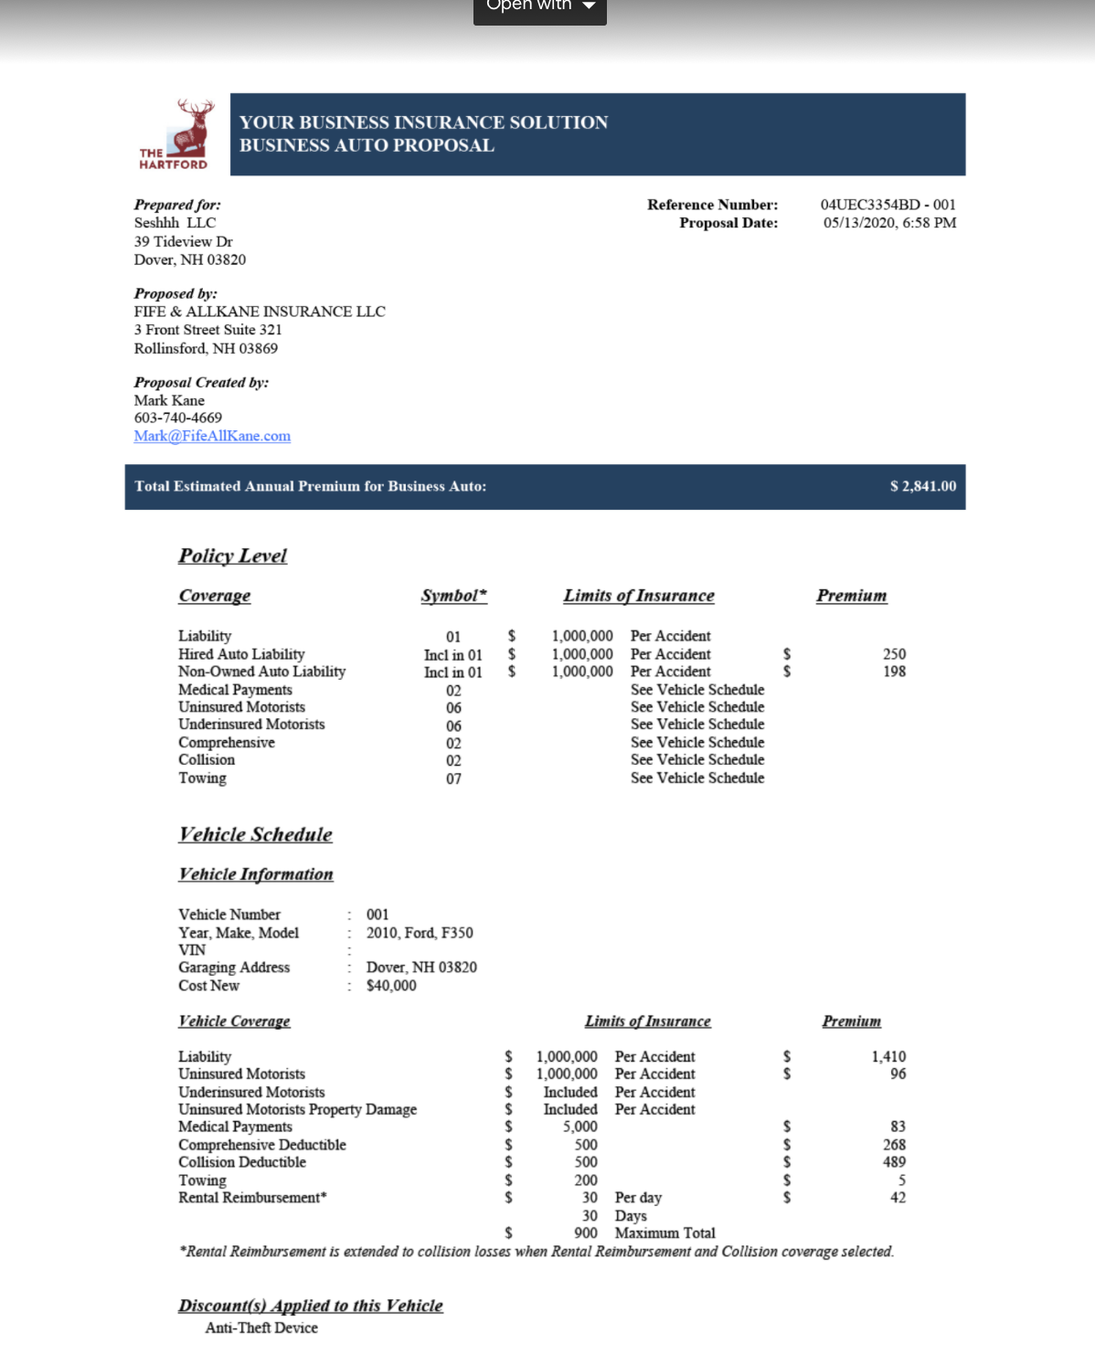
Business Owners Quote: